**Threads en tomcat**

[**https://stackoverflow.com/questions/39002090/spring-boot-limit-on-number-of-connections-created**](https://stackoverflow.com/questions/39002090/spring-boot-limit-on-number-of-connections-created)

**Rendimiento**

[**http://grokbase.com/t/postgresql/pgsql-general/0595fecj8b/setting-up-a-database-for-10000-concurrent-users**](http://grokbase.com/t/postgresql/pgsql-general/0595fecj8b/setting-up-a-database-for-10000-concurrent-users)

**improve performance in postgres**

[**https://www.openscg.com/2016/09/improve-postgresql-windows-performance-by-100/**](https://www.openscg.com/2016/09/improve-postgresql-windows-performance-by-100/)

[**http://www.postgresql-archive.org/RFC-Change-the-default-of-update-process-title-to-off-td5914788.html**](http://www.postgresql-archive.org/RFC-Change-the-default-of-update-process-title-to-off-td5914788.html)

**IMPLEMENTACIóN DE LLAVES SIMETRICAS CON CIFRADO CHECKSUM**

INTEGRIDAD CON CHEKSUM

Convierto lo que voy a enviar con un checksum y obtengo el long.

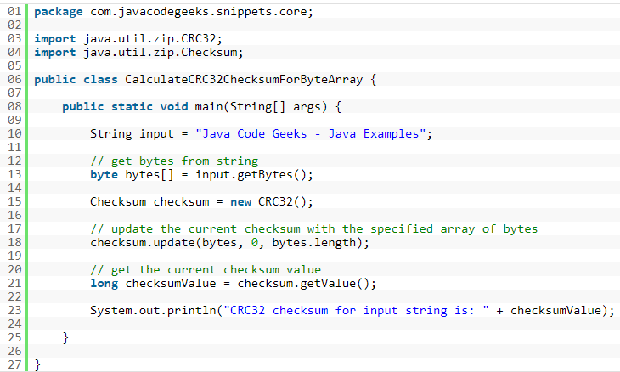

Online cheksum <https://www.tools4noobs.com/online_php_functions/crc32/>

Le debo agregar al checksum una llave. No me importa que el de la mitad vea el body,

Se implentaran llaves simétricas para el checksum, para que al destino puede aplicarle al mensaje el checksum y sumarle un hexa para garantizar que el mensaje no fue modificado.

Android:

<https://developer.android.com/reference/java/util/zip/CRC32.html>

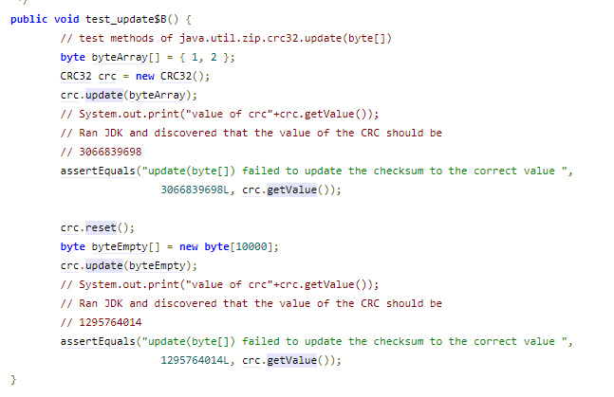

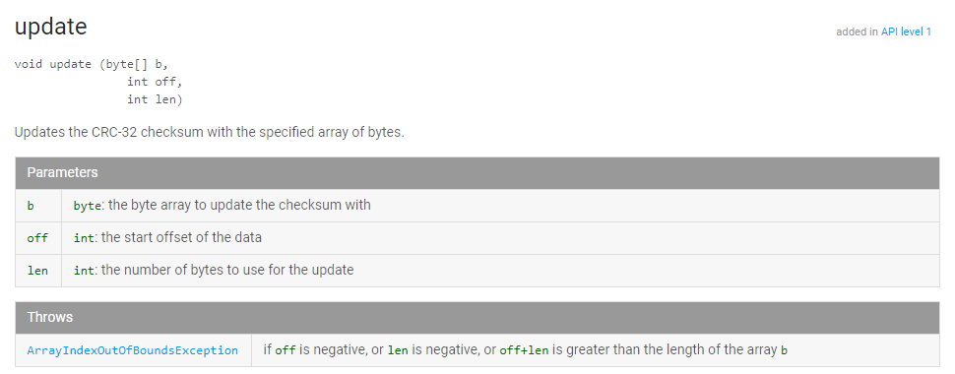

**PARECE QUE EL OFFSET PODRIA SER LA LLAVE PRIVADA SIMETRICA**

Envía: Mensaje – Hago cheksum – al cheksum le sumo la llave.

Recibe: Mensaje – Hace checksum le suma la llave a ver si da.

**VENTAJAS:** *crc es mas rapido que hash, rendimiento. Es mucho mas facil de implementar en dispositivos moviles, ademàs android ya lo tiene.

y valida la integridad de los datos mucho mejor que el checksum.

**NO DEBO LEER AL OTRO LOADO, PORQUE NO VA CIFRADO, SOLO LE HAGO EL CHEKSUM Y QUE DÈ IGUAL.**

TOMO EL MENSAJE Y LE HAGO EL CHECKSUM CON EL OFFSET QUE TENGO COMO LLAVE PRIVADA

Y listo, comparo que dé el mismo checksum.

**Timestamp?**

**Enviar parámetros en header con httpurlconnection**

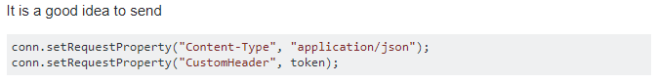



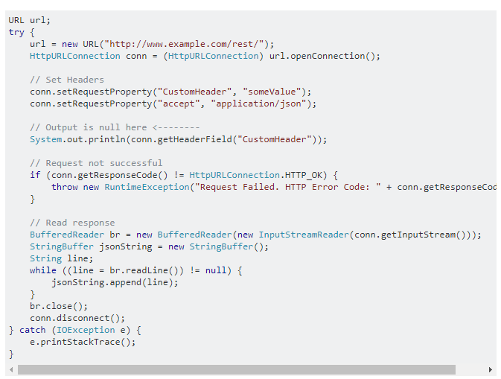

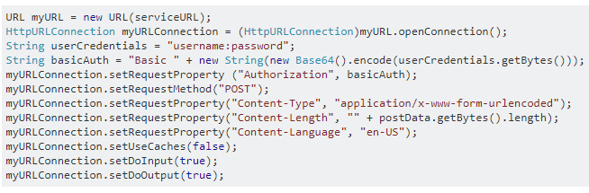

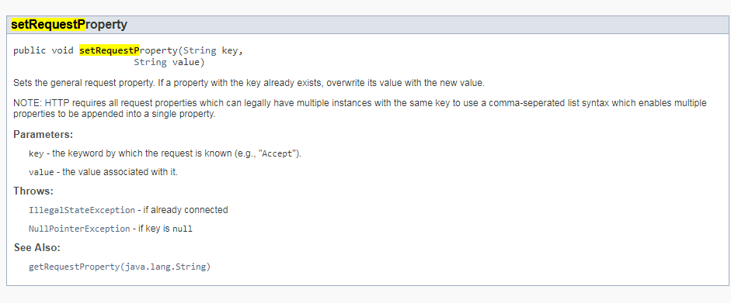

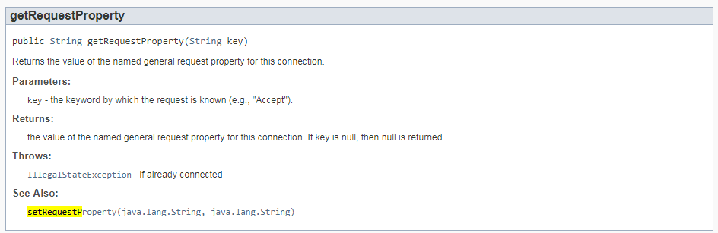

[**https://stackoverflow.com/questions/3892682/passing-parameters-in-the-message-header-with-a-rest-api**](https://stackoverflow.com/questions/3892682/passing-parameters-in-the-message-header-with-a-rest-api)

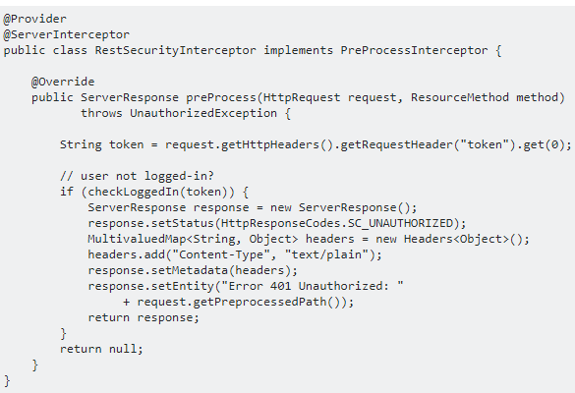

**ENVIO DESDE APP MOVIL**

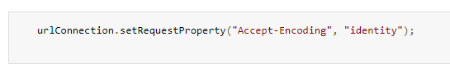

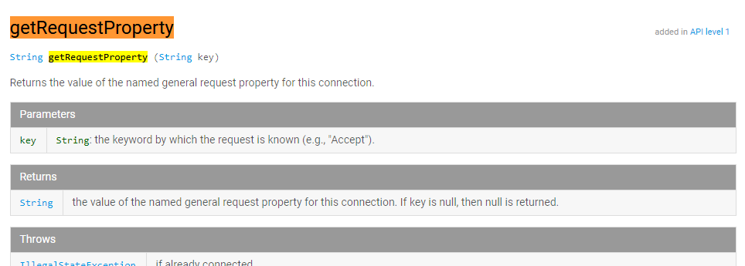

[**https://stackoverflow.com/questions/43320017/send-header-value-using-httpurlconnection**](https://stackoverflow.com/questions/43320017/send-header-value-using-httpurlconnection)

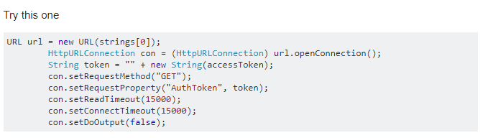

**Ya tendría la parte del móvil. Envio y recibir**

1. **CREAR METODO DE CRC32 QUE PASE EL PARAMETRO Y RETORNE EL LONG**

**Lado del servidor con spring boot**

**PRUEBAS**

**ALEATORIO ALTERAR EL MENSAJE CON OTRO CLIENTE EN LA MITAD**

**MARCA DE TIEMPO CON TIMESTAMP**

Security test

<https://www.soapui.org/security-testing/getting-started.html>

Morpheus security

<http://www.drchaos.com/morpheus-man-in-the-middle-security-tool/>

--- ventajas ssl MITM

<https://www.blackmoreops.com/2015/12/22/man-in-the-middle-attack-using-kali-linux/>

MONGO DB AND SPRING BOOT

<https://www.petrikainulainen.net/programming/spring-framework/creating-a-rest-api-with-spring-boot-and-mongodb/>

man in the middle attack

<https://www.youtube.com/watch?v=XW5naPY4FsA>

Over the years a bunch of students don't really 'care about encrypting the passwords' or avoid using SSL as a possible solution (i.e., an SHA-128/256 hash of the password is sent over the wire in case of plain text but still no SSL. So I can conduct a replay attack as a result).

I want to be able to 'demo the dangers' of the man-in-the-middle (MITM) and am not sure how to go about it. Students question if someone is really able to pull it off and are curious on the *how*. I thought it'd be good to 'show it to them'.

You can also use SSLstrip which will attempt to remove the SSL protection on some websites and give you access to clear text credentials.

<https://security.stackexchange.com/questions/31653/how-to-demonstrate-man-in-the-middle-attack>

SSL is better

--------------------------------------

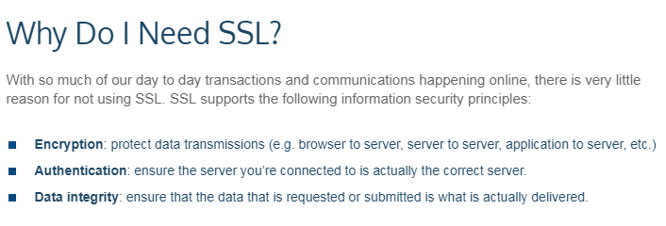

Benefits of encript

<http://newsroom.kaspersky.eu/fr-be/news/news-article/article/encryption-five-major-benefits-2/>

**Benefit 4: Guarantee Data Integrity**

Targeted data theft is one thing, but another way to misuse data is through manipulation. Even though a hacker may have absolutely no interest in the information in question, he or she can manipulate specific data to disrupt corporate communications. If encrypted data is used, the recipient will definitely notice that it has been tampered with.

**https protege de man in the middle**

Https is based on public/private-key cryptography. This basically means that there is a key pair: The public key is used for encryption and the secret private key is required for decryption

ssl in web service

https://stackoverflow.com/questions/6810634/how-to-make-simple-ssl-thru-web-services

//---------------------------------------------

foro

<https://stackoverflow.com/questions/16690442/encrypting-exchanged-data-in-a-restful>

# [Encrypting exchanged data in a RESTful](https://stackoverflow.com/questions/16690442/encrypting-exchanged-data-in-a-restful)

I have created a Restfull web-service in java that is consumed by an android application. The work is almost done.

I recommend you to use **HTTPS** for your need. **SSL/TLS provide better encryption decryption over https**. **And you don't need to reinvent wheels for this basic purpose**. If you are using **tomcat to host REST web serivces then here is a simple tutorial to turn on SSL in tocamt**

**Make tomcat SSL**

<https://dzone.com/articles/setting-ssl-tomcat-5-minutes>

//-------------------

<https://security.stackexchange.com/questions/38388/ssl-vs-encryption>

I am working on creating an android mobile application which needs to connect to a server from time to time. The application makes use of sensitive data which I would not like to get into the wrong hands.

Using [Android's DefaultHttpClient](https://developer.android.com/reference/org/apache/http/impl/client/DefaultHttpClient.html) you can establish an HTTPS connection and configure it to trust only certain certificates. It's quite easy to use and it's already there. You can even use [SSLSocket](https://developer.android.com/reference/javax/net/ssl/SSLSocket.html) if you don't fancy HTTP. The main point is: **don't do your own crypto**.

As for the overhead, don't worry, most of the time it's negligible. Your data is sensitive and the communication will happen from time to time. As far as I can see, there's nothing against using SSL here.

**La mayoría de tiempo es insignificante.**

The best solution for transport security is TLS/SSL. It's supported by default and the overhead is minimal. **It support implicit authentication as well.**

**HTTPS PERFORMANCE**

**https://www.keycdn.com/blog/https-performance-overhead/**

<https://stackoverflow.com/questions/149274/http-vs-https-performance>

Measure (using a tool such as Firebug) the page load times while the server is on the end of a simulated high-latency link. Tools exist to simulate a high latency link - for Linux there is "netem". Compare HTTP with HTTPS on the same setup.

The latency can be mitigated to some extent by:

* Ensuring that your server is using HTTP keepalives - this allows the client to reuse SSL sessions, which avoids the need for another handshake
* Reducing the number of requests to as few as possible - by combining resources where possible (e.g. .js include files, CSS) and encouraging client-side caching
* Reduce the number of page loads, e.g. by loading data not required into the page (perhaps in a hidden HTML element) and then showing it using client-script.

<https://www.tunetheweb.com/blog/http-versus-https-versus-http2/>

Se entiende que el impacto en el rendimiento de HTTPS ya no es una barrera para la adopción de sitios web.

http2 improve performance in https tan http

--Prueba de rendimiento HTTPS

<http://www.httpvshttps.com/>

Por lo que realmente se parece HTTPS causar ningún impacto notable de rendimiento para sitios web sencillos, como ha sido declarado por la mayoría de los expertos desde hace algún tiempo.

El otro punto obvio es que HTTP / 2 es **mucho** más rápido que HTTP o HTTPS, aunque sólo está disponible en HTTPS para los navegadores web. Esto es lo que sentí fue el punto engañoso de la [https://www.httpvshttps.com/](https://translate.googleusercontent.com/translate_c?act=url&depth=1&hl=es&ie=UTF8&prev=_t&rurl=translate.google.com&sl=en&sp=nmt4&tl=es&u=https://www.httpvshttps.com/&usg=ALkJrhhYhK7evYvOgRwhijgZmH63__72bA) sitio web, ya que no fue HTTPS que causó el desempeño presumir, pero es realmente impresionante lo mucho que hace una diferencia HTTP / 2 - Incluso en un sitio más pequeño de 36 imágenes. Por supuesto, el sitio de 360 ​​imágenes sigue siendo un ejemplo extremo y no vas a ver un 91% de mejora simplemente encendiendo HTTPS - incluso con HTTP / 2 para la mayoría de los sitios. Sin embargo incluso el sitio más pequeño de la imagen 36 ve una mejora enorme del 70% en HTTP / 2 - mucho más que habría esperado.

HTTPS en particular es una tecnología bien establecida ahora y con iniciativas como [Let's Encrypt](https://translate.googleusercontent.com/translate_c?act=url&depth=1&hl=es&ie=UTF8&prev=_t&rurl=translate.google.com&sl=en&sp=nmt4&tl=es&u=https://letsencrypt.org/&usg=ALkJrhiQxhvogV2vfvGtGDiuSi1aGlToCA) nunca ha sido más fácil o más barato obtener un certificado HTTPS para su sitio web. Hay [muchas razones para usar HTTPS](https://translate.googleusercontent.com/translate_c?act=url&depth=1&hl=es&ie=UTF8&prev=_t&rurl=translate.google.com&sl=en&sp=nmt4&tl=es&u=https://scotthelme.co.uk/still-think-you-dont-need-https/&usg=ALkJrhg46uHzN9_GLUeubPMv0bdKAF_zTQ) y va a ser más difícil y más difícil mantener un sitio HTTP solo como[funciones de reserva de](https://translate.googleusercontent.com/translate_c?act=url&depth=1&hl=es&ie=UTF8&prev=_t&rurl=translate.google.com&sl=en&sp=nmt4&tl=es&u=https://developers.google.com/web/updates/2016/04/geolocation-on-secure-contexts-only%3Fhl%3Den&usg=ALkJrhiJ64hhPwXWRuWIhowo8aU77kpZwA) navegadores web [para sitios HTTPS](https://translate.googleusercontent.com/translate_c?act=url&depth=1&hl=es&ie=UTF8&prev=_t&rurl=translate.google.com&sl=en&sp=nmt4&tl=es&u=https://developers.google.com/web/updates/2016/04/geolocation-on-secure-contexts-only%3Fhl%3Den&usg=ALkJrhiJ64hhPwXWRuWIhowo8aU77kpZwA) . Si usted no está en HTTPS entonces usted debe mirarlo ahora. Estas pruebas demuestran que el impacto en el rendimiento no es ni siquiera notable para la mayoría de los sitios

API REST Y HTTP/2

<https://www.api2cart.com/blog/rest-api-services-can-expect-http2/>

varias

<https://stackoverflow.com/questions/31692868/rest-api-with-http-2>

<https://community.atlassian.com/t5/JIRA-Core-questions/Rest-API-not-working-with-HTTP-2/qaq-p/83822>

<https://www.smashingmagazine.com/2016/02/getting-ready-for-http2/>

<https://www.quora.com/How-does-HTTP-2-affect-RESTful-APIs>

1. Dejar escalabilidad asi como está, cindy y alex colaborarnos en disponibilidad

2. Que nos reunamos el Domingo en la mañana temprano, se hacela entrega de lo realizado a Juve,kevin y yo. armamos el documento y laspruebas y mientras los dias siguientes alex y cindy nos asisten y van experimentando mas , que solo sea cambiar eldocumento.

----------------------

Integridad

Integrity, non repudiation—Making sure that a message remains unaltered during transit by having the sender digitally sign the message. A digital signature is used to validate the signature and provides non-repudiation. The timestamp in the signature prevents anyone from replaying this message after the expiration.

https protege de man in the middle

Https is based on public/private-key cryptography. This basically means that there is a key pair: The public key is used for encryption and the secret private key is required for decryption.

ssl in web service

https://stackoverflow.com/questions/6810634/how-to-make-simple-ssl-thru-web-services

checksum

https://icepay.com/downloads/tech-docs/ICEPAY_REST_API_Manual.pdf

-------------------------

--Porque usar CRC en lugar de checksum

http://asktheoracle.com/blog/why-you-should-avoid-checksums-and-use-crcs-instead/

checlsum with CRC32 IN JAVA

https://examples.javacodegeeks.com/core-java/util/zip/calculate-crc32-checksum-for-byte-array/

IN ANDROID

https://developer.android.com/reference/java/util/zip/CRC32.html

CRC vs hash

*crc es mas rapido que hash, rendimiento. Es mucho mas facil de implementar en dispositivos moviles, ademàs android ya lo tiene.

y valida la integridad de los datos mucho mejor que el checksum.

*

explicacion CRC

http://www.repairfaq.org/filipg/LINK/F_crc_v31.html#CRCV_004

probelmas con crc

https://stackoverflow.com/questions/20993557/wrong-crc32-hash-in-androidç

SHA 1

https://www.mkyong.com/java/how-to-generate-a-file-checksum-value-in-java/

---------------------------------------------

SHA1 IN ANDROID

Message digest

https://developer.android.com/reference/java/security/MessageDigest.html

implementar sha 1 in android

https://karanbalkar.com/2013/05/tutorial-28-implement-sha1-and-md5-hashing-in-android/

** LOGIN

http://www.hackpundit.com/simple-login-android-app/

read status

ublic static JSONObject requestWebService(String serviceUrl) {

disableConnectionReuseIfNecessary();

HttpURLConnection urlConnection = null;

try {

// create connection

URL urlToRequest = new URL(serviceUrl);

urlConnection = (HttpURLConnection)

urlToRequest.openConnection();

urlConnection.setConnectTimeout(CONNECTION_TIMEOUT);

urlConnection.setReadTimeout(DATARETRIEVAL_TIMEOUT);

// handle issues

int statusCode = urlConnection.getResponseCode();

if (statusCode == HttpURLConnection.HTTP_UNAUTHORIZED) {

// handle unauthorized (if service requires user login)

} else if (statusCode != HttpURLConnection.HTTP_OK) {

// handle any other errors, like 404, 500,..

}

// create JSON object from content

InputStream in = new BufferedInputStream(

urlConnection.getInputStream());

return new JSONObject(getResponseText(in));

} catch (MalformedURLException e) {

// URL is invalid

} catch (SocketTimeoutException e) {

// data retrieval or connection timed out

} catch (IOException e) {

// could not read response body

// (could not create input stream)

} catch (JSONException e) {

// response body is no valid JSON string

} finally {

if (urlConnection != null) {

urlConnection.disconnect();

}

}

return null;

}

/**

* required in order to prevent issues in earlier Android version.

*/

private static void disableConnectionReuseIfNecessary() {

// see HttpURLConnection API doc

if (Integer.parseInt(Build.VERSION.SDK)

< Build.VERSION_CODES.FROYO) {

System.setProperty("http.keepAlive", "false");

}

}

private static String getResponseText(InputStream inStream) {

// very nice trick from

// http://weblogs.java.net/blog/pat/archive/2004/10/stupid_scanner_1.html

return new Scanner(inStream).useDelimiter("\\A").next();

--------------------------

------------------------------

** llenar ddl

Tuto

https://www.mkyong.com/android/android-spinner-drop-down-list-example/

http://www.compiletimerror.com/2013/09/android-spinnersdropdownlist-tutorial.html

otro

http://abhiandroid.com/ui/spinner

------------------------

** Secure service

https://stackoverflow.com/questions/13025034/writing-a-secure-rest-web-service

http://androidcracking.blogspot.com.co/2011/10/if-app-requires-unlocker-key-app-its.html

checlsum with CRC32 IN JAVA

https://examples.javacodegeeks.com/core-java/util/zip/calculate-crc32-checksum-for-byte-array/

IN ANDROID

https://developer.android.com/reference/java/util/zip/CRC32.html

CHECKSUM --

01

package com.javacodegeeks.snippets.core;

02

03

import java.util.zip.CRC32;

04

import java.util.zip.Checksum;

05

06

public class CalculateCRC32ChecksumForByteArray {

07

08

public static void main(String[] args) {

09

10

String input = "Java Code Geeks - Java Examples";

11

12

// get bytes from string

13

byte bytes[] = input.getBytes();

14

15

Checksum checksum = new CRC32();

16

17

// update the current checksum with the specified array of bytes

18

checksum.update(bytes, 0, bytes.length);

19

20

// get the current checksum value

21

long checksumValue = checksum.getValue();

22

23

System.out.println("CRC32 checksum for input string is: " + checksumValue);

24

25

}

26

27

}

------------------------------

http://codetheory.in/understanding-and-populating-android-spinners/

<Spinner

android:layout_width="match_parent"

android:layout_height="wrap_content"

android:id="@+id/country" />

Spinner countryView = (Spinner) findViewById(R.id.country);

// Create an adapter from the string array resource and use

// android's inbuilt layout file simple_spinner_item

// that represents the default spinner in the UI

ArrayAdapter adapter = ArrayAdapter.createFromResource(this, R.array.country_array, android.R.layout.simple_spinner_item);

// Set the layout to use for each dropdown item

adapter.setDropDownViewResource(android.R.layout.simple_spinner_dropdown_item);

countryView.setAdapter(adapter);

---------------------

obtener selecteditem

// Spinner view object

Spinner countryView = (Spinner) findViewById(R.id.country);

// Spinner view value

String country = countryView.getSelectedItem().toString().trim();

-------------------------

Evento

countryView.setOnItemSelectedListener(new AdapterView.OnItemSelectedListener() {

@Override

public void onItemSelected(AdapterView<?> parent, View view, int position, long id) {

String country = parent.getItemAtPosition(position).toString();

Toast.makeText(LoginActivity.this, country, Toast.LENGTH_SHORT).show();

}

@Override

public void onNothingSelected(AdapterView<?> parent) {

}

});

---------------------

send voice

<https://stackoverflow.com/questions/4966910/androidhow-to-upload-mp3-file-to-http-server>

1. Integridad hacer pruebas de carga con https

2. Integridad hacer implementación de CRC en android y servicio

3. pruebas funcionales de la app

4. Interfaz

5. Quitar de la app la transaccion de cindy

6. poner of https://www.openscg.com/2016/09/improve-postgresql-windows-performance-by-100/ postgres